Disney Principled BRDF,迪斯尼原则的BRDF

0.What
在SIGGRAPH 2012会议上,工作于迪斯尼动画工作室的Brent Burly演讲了著名的主题:Physically Based Shading at Disney,迪斯尼的BRDF(Disney Principled BRDF),奠定了后续游戏行业和电影行业PBR的方向和标准,后续的主流游戏引擎,3D渲染器及动画制作软件大多基于此方案或变种实现的

迪斯尼原则的BRDF用少量简单易懂的参数和高度完善的美术工作流程,大大简化了此前复杂的PBR的参数和制作流程,它是艺术导向(Art Directable)的着色模型,而不完全是物理正确(Physically Correct)

Blender的Cycles引擎支持类似的材质(Principled BSDF),且和其他一些软件的实现兼容,效果好,建议学习…

1.参数
Base Color
Defines the surface color.

Roughness
Surface roughness: controls diffuse, specular and transmission response.

Metallic
The metallic-ness (0 = dielectric, 1 = metallic). This is a linear blend between two different models. The metallic model has no diffuse component and also has a tinted incident specular, equal to the base color.

Specular
Incident specular amount.

Specular Tint
Tints incident specular towards the base color. Grazing specular is still achromatic.

Anisotropic
Degree of anisotropy. This controls the aspect ratio of the specular highlight (0 = isotropic, 100 = max anisotropic).

Anisotropic Rotation
Rotates the direction of anisotropy, with 1.0 going full circle.

Clear Coat
A second, special-purpose specular lobe.

Clear Coat Glossiness
Controls clear coat glossiness (0 = "satin" appearance, 100 = a "gloss" appearance).

Specular Color
Defines the specular color.

Metallic Edge Color
Color bias as the viewing direction becomes parallel to the surface.

Reflection Exit Color
Sets the reflection color when there is no more bounce along the path.

Subsurface
Controls diffuse shape using a subsurface approximation.

Subsurface Color
Defines the scattering color inside the material.

Subsurface Radius
Sets the light penetration distance inside the material.

Subsurface Group
Name of the group among which illumination propagates between SSS materials.

Transmission
An additional transmissive component.

Transmission Tint
Amount to tint transmission towards base color.

Transmission Color
Defines the transmission color.

Transmission Exit Color
Sets the transmission color when there is no more bounce along the path.

Sheen
An additional grazing component, primarily intended for cloth.

Sheen Tint
Amount to tint sheen towards base color.

Sheen Color
Defines the sheen color.

Emission
Strength of the emission.

Emission Color
Defines the emission color.

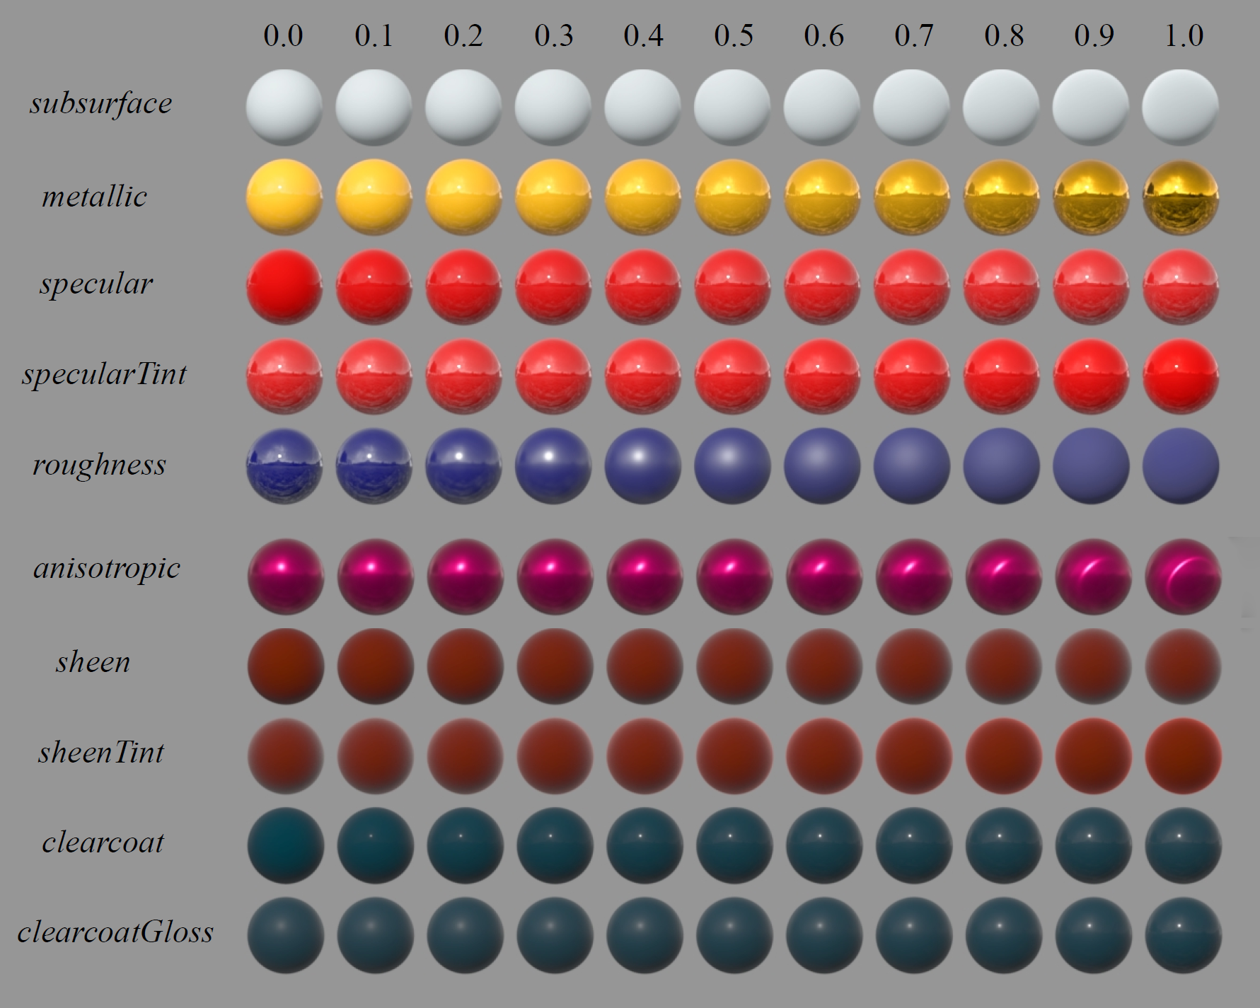
效果图

Ref:
https://clarissewiki.com/4.0/disney-principled.html

